User Manual: Advantzware Open Analytics (AOA)

| September-20 |

**Document Overview**

**Documentation Goals**

This documentation is intended to provide instruction for ***using the Open Analytics system****.*

**Table of Contents**

**Query Creation** 3

Overview 3

Set Up Query 3

Modify Query 6

Schedule Task 13

Change Parameters 15

Schedule Task 17

**Parameter Screen** 19

Overview 19

AOA Report Launcher 19

Report – Machine Transactions 21

Report Parameters 21

Show/Hide Sections 21

Report Columns 22

Render Report 22

View Report 23

View in Web Browser 23

Export to Excel 26

Batch Scheduler 28

# **Query Creation**

## Overview

When attempting to use an AOA Report in the Auto Scheduler, if the output format desired is Excel, there is an issue in how it renders if columns are deselected and/or the column order is changed.

The process first creates the report in AOA format, then attempts to place the data into the Excel columns based on the pixel position. This is quite complicated and prone to the Excel process not rendering as anticipated.

If exporting to Excel via the Auto Scheduler is required, this guide will explain how to extract the AOA query from the report and using the Excel DataPA Add-In, show how to use the Query Wizard for modifying the Query to create the desired Excel results.

### Set Up Query

#### Open AOA Report

***“Double-Click”*** the *AOA Report* from Windows Explorer (or open Report Designer and open the AOA Report.

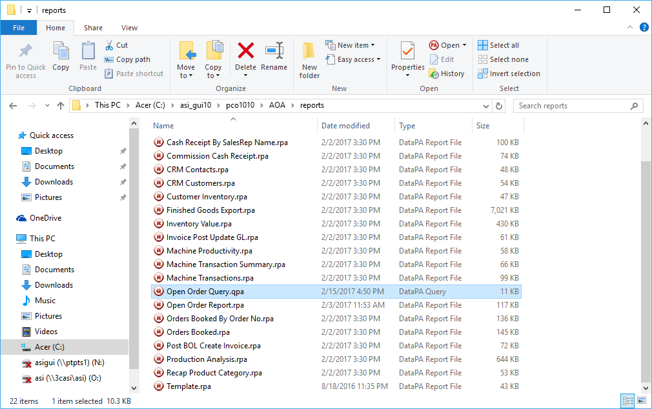

#### Share Query

Select the ***“Setup”*** menu option at the top of the screen, and then click ***“Share Query”*** from the drop-down menu.

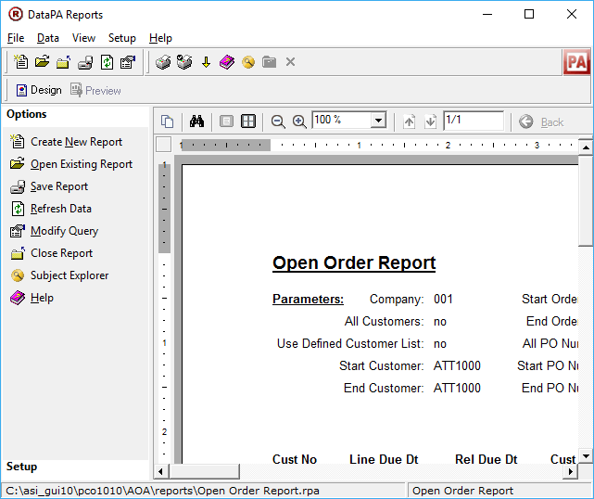

#### Save Report

The user should keep the default filename on this screen, and not attempt any changes. The default name given is the Report name, with a “.gpa” extension. Select the ***“Save”*** button at the bottom of the screen.

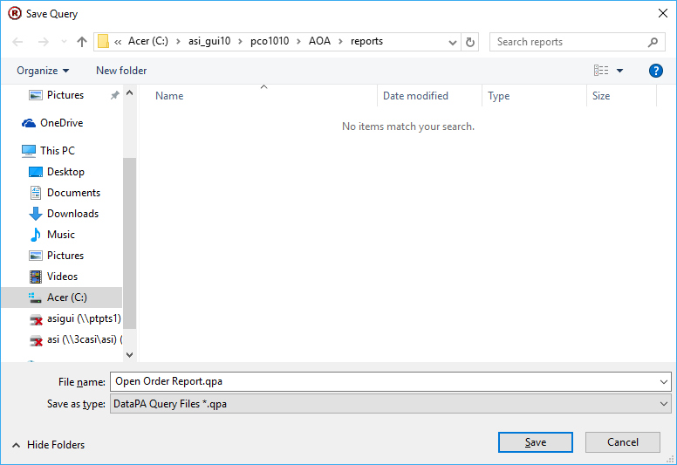

Once the report has been saved, close the *Report Designer*.

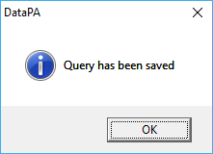

### Modify Query

#### Open Excel

Open the *Excel* program, and locate the ***“Add-Ins”*** tab at the top of the screen.

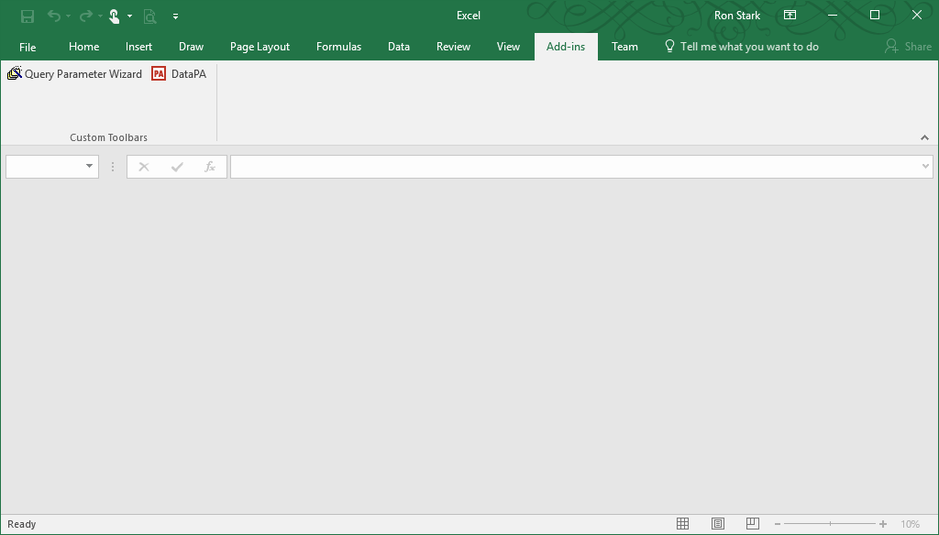

#### DataPA

Click the “***DataPA***” Add-In which will run the *Query Wizard*.

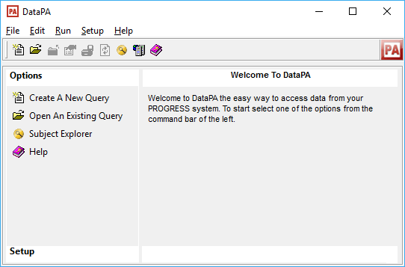

#### Open Query

Open an existing query using Windows Explorer.

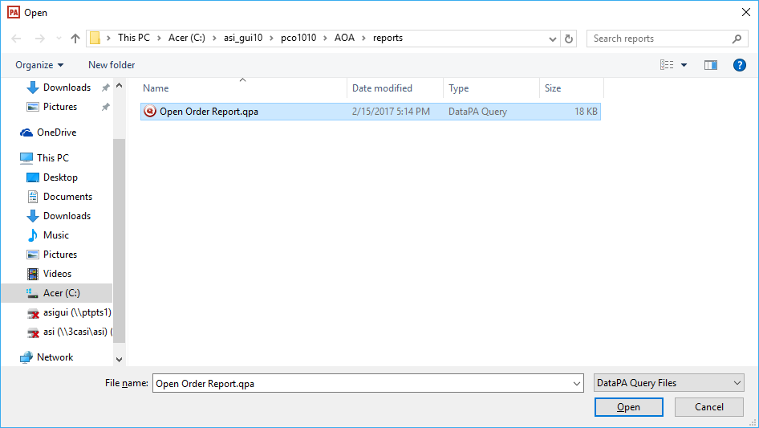

#### Modify Query

Select the ***“Modify Query”*** menu option, and then select the ***“Next”*** button at the bottom of the *Open Order Report – Name and Description* screen.

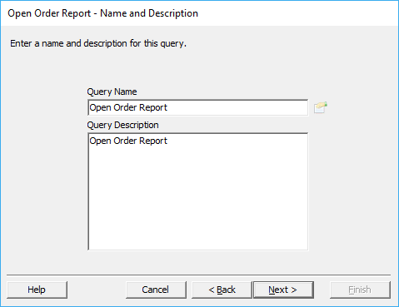

#### Open Order Report – Select Subject

The user should keep the default selections on this screen, and not attempt any changes. Then select the ***“Next”*** button at the bottom of the screen.

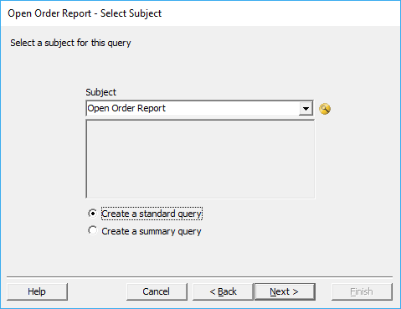

#### Open Order Report – Define Filter Conditions

Select the ***“Add”*** button.

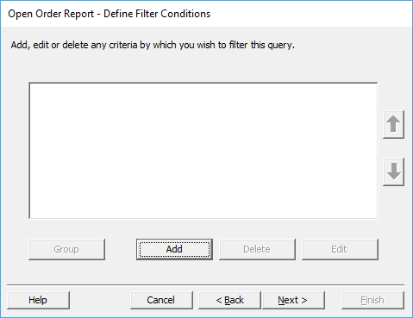

#### Query Condition

Select the ***“rowType”*** option from the *Field* drop-down menu. Make sure that the toggle box next to the ***“Fixed Value”*** selection is filled in, then enter ***“Data”*** in the *Fixed Value* field.

These selections are done because at the top of the dataset returned by AOA is a record with *MetaData* used to parse and structure the resulting AOA Reports. If this “***rowType***” query condition is not set, this record will appear in the Excel sheet as the first record.

Once the proper selections have been made, select the ***“Okay”*** button at the bottom of the *Query Condition* screen, then select the ***“Next”*** button at the bottom of the following screen.

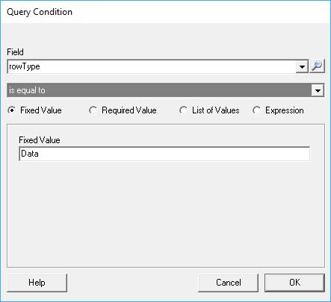

#### Open Order Report – Select Fields

The user may now remove any fields that are not desired to appear in the Excel sheet by highlighting them within the *Selected* column, and clicking the ***“ << “*** button between the two columns.

Please Note; Any fields labeled *Sort*, *rowType*, *Parameters* and/or *Index*, should be unselected. Also, any changes in which the order of columns should be changed, is done here using the “***Move Up***” and “***Move Down***” buttons.

Once the user is satisfied with their column selections, click the ***“Next”*** button at the bottom of the screen.

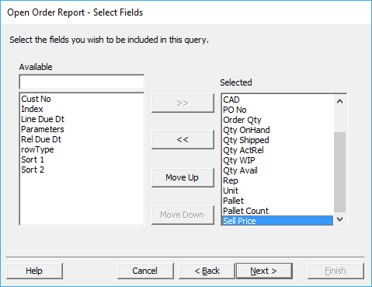

#### Open Order Report – Sort Criteria

If the sort order needs adjusting, the user can use this screen to make those changes. Normally, this should remain as configured. Once the user is satisfied with their selections, click the ***“Next”*** button at the bottom of the screen.

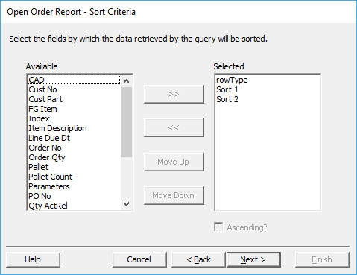

#### Open Order Report – Add Multiple Subjects to Query

The user should keep the default selections on this screen, and not attempt any changes. Then select the ***“Next”*** button at the bottom of the screen.

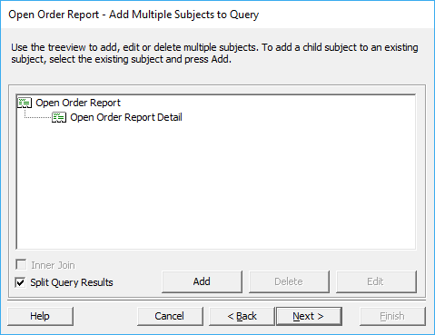

#### Open Order Report – Finished!

Select the ***“Finish”*** button at the bottom of the screen.

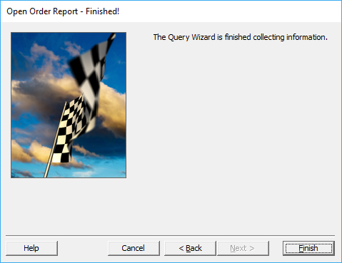

#### Save Query

Select the ***“Save Query”*** option.

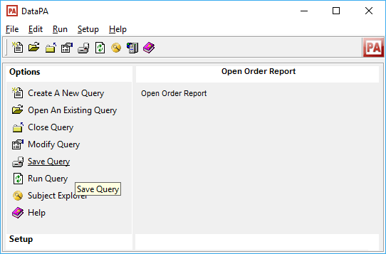

### Schedule Task

Open the *Scheduler*. If a *Task* does not already exist, the user must create one.

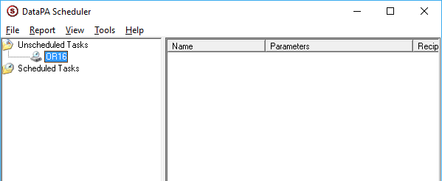

#### Report Details

Select the ***“Report”*** tab at the top of the screen, and then click ***“Add Report”*** from the drop-down menu. Once the *Report Details* screen has opened, select the ***“ … ”*** button to the right of the *Filename* field.

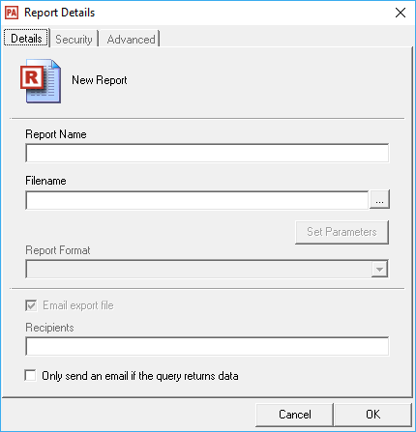

#### Filename

The user should select their desired query from the list of available report in Windows Explorer.

Please Note: The report must have a .gpa extension in order for the program to use it.

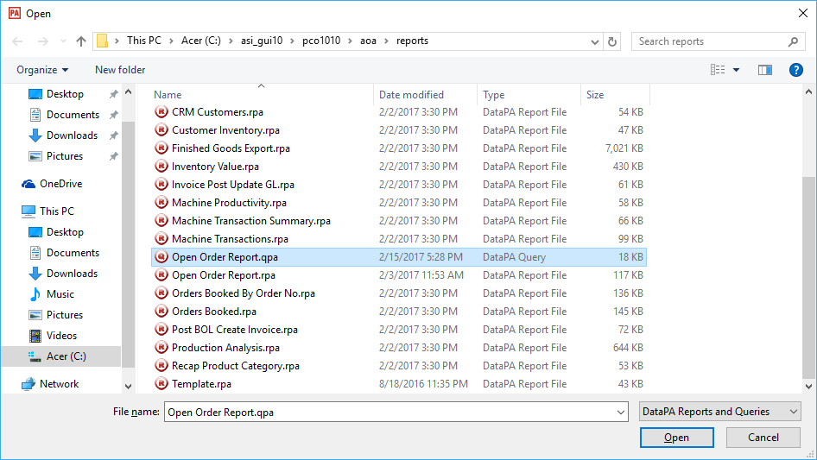

#### Finished Report Details

The program will automatically select the *Excel Workbook (xlsx)* format. The user may now populate their desired contacts into the *Recipients* field, then select the ***“OK”*** button at the bottom of the screen.

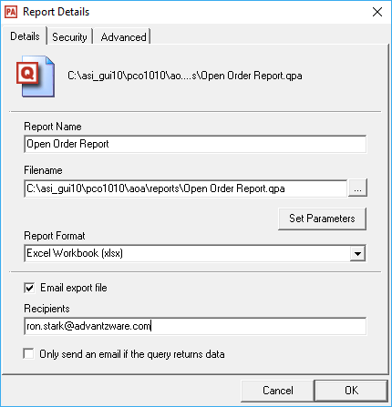

### Change Parameters

***“Right-Click”*** the desired report and select “***Change Parameters***” from the drop-down menu. Use the same *Parameter* values for company, batch, and user that would normally be used when running the AOA Report this Query was created from.

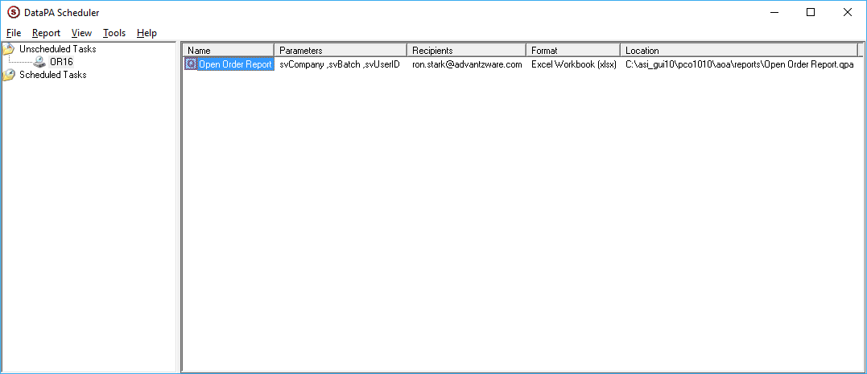

#### Enter Condition Value - Company

Enter the *Company* value that the batch was created under. Then select the ***“Next”*** button at the bottom of the screen.

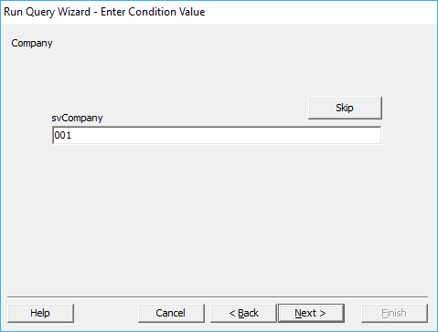

#### Enter Condition Value – Batch Sequence

Enter the *Batch* value. Then select the ***“Next”*** button at the bottom of the screen.

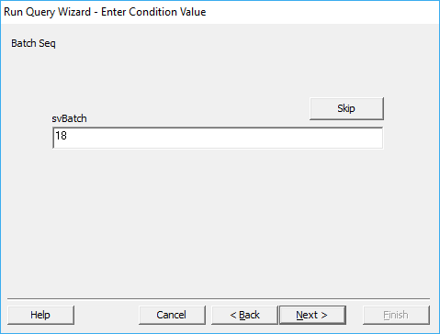

#### Enter Condition Value – User ID

Enter the *User ID* value of the batch owner. Then select the ***“Next”*** button at the bottom of the screen.

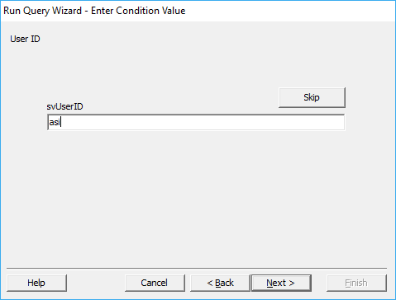

#### Run Query Wizard – Finished!

Select the ***“Finish”*** button at the bottom of the screen.

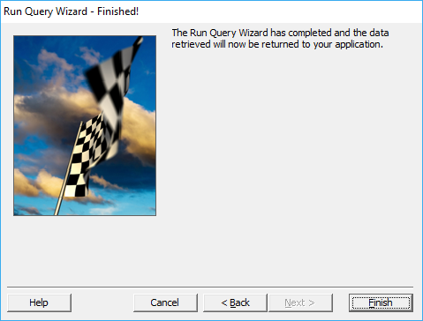

### Schedule Task

At this point the Task can be scheduled for future use, or the user can ***“Right-Click”*** the Task and perform the “***Run Now”*** option from the drop-down menu to test both the output is as desired and/or the Email Recipients receive the Excel Sheet.

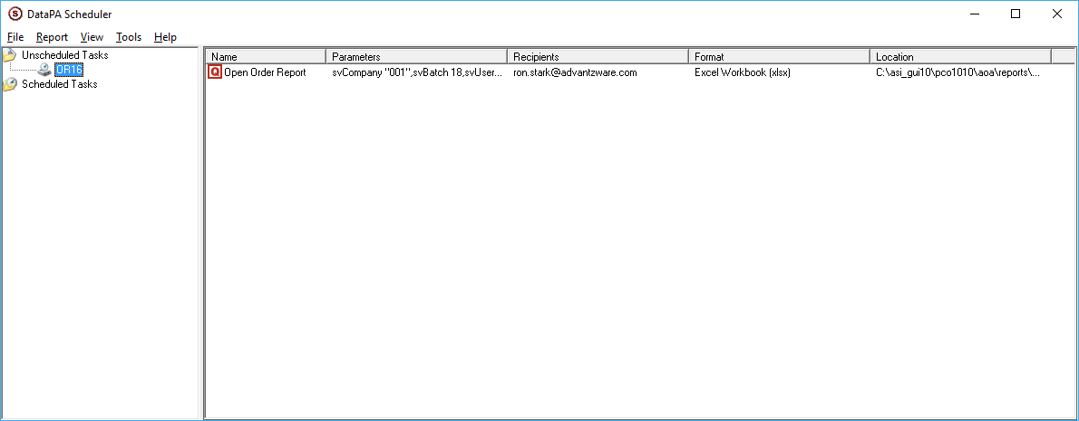

The user can review the log file by selecting “***Tools***” and then “***View log file***” from the drop-down menu.

#### Excel File

The *Excel* file should render as desired.

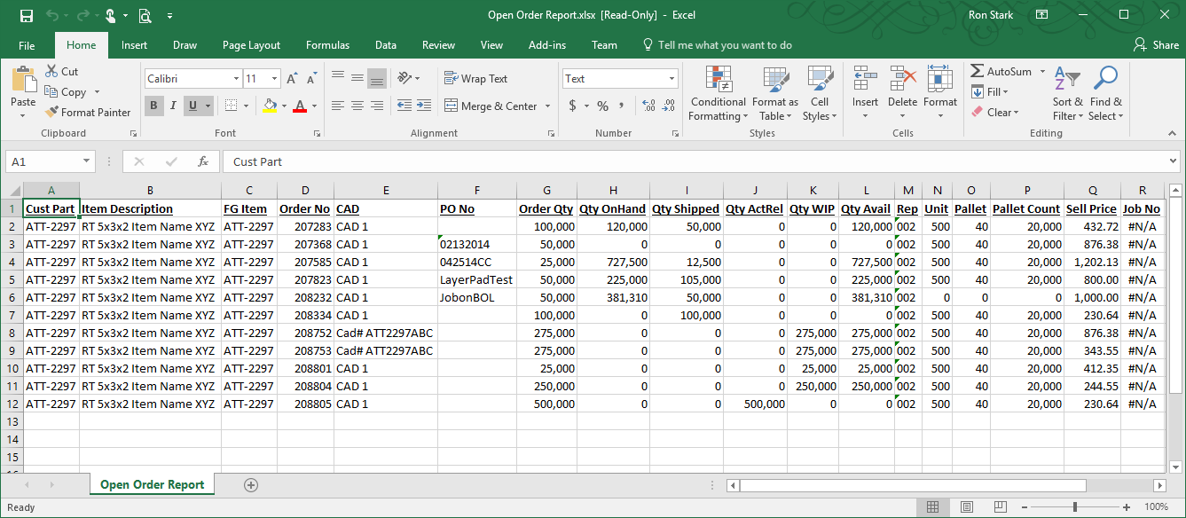

Please Note: The selections chosen for showing various sections of an AOA Report and/or column selections/order changes in the AOA Parameter screen are ignored. The Query only uses the Parameter values located on the left side of the screen for selecting ranges, etc.

# **Parameter Screen**

## Overview

Full functionality to render AOA Reports and Dashboards to a locally installed Web Browser, requires the installation/configuration of a Progress Application Server, installation/configuration of Internet Information Services (IIS) and AOA Report/Dashboard Writer on the Advantzware Server.

Additionally, our AOA Batch Scheduler is available for submitting AOA Reports to run off hours and/or on a predetermined schedule daily, weekly and or monthly as desired.

Please Note: All AOA Reports will render into Excel regardless if any of the above components are installed.

## AOA Report Launcher

From anywhere within the Advantzware System, type ***“Control” – “Alt” – “R”*** to invoke the AOA Report Launcher.

Please Note: Typing ***“Control” – “Alt” – “D”*** to invoke the AOA Dashboard Launcher.

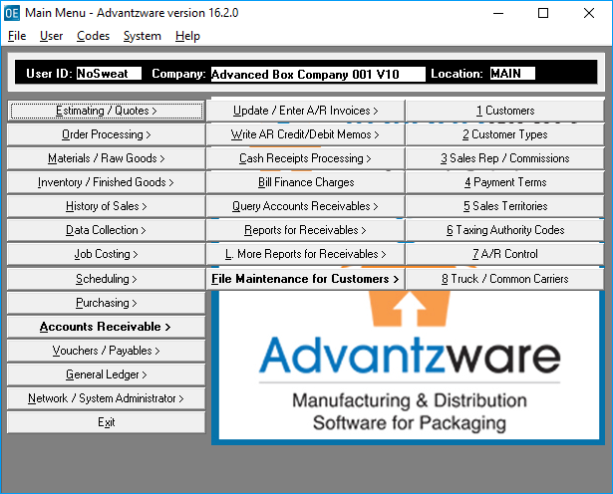

### AOA Report Launcher

By default, the *Launcher* will display all the *AOA Reports* available in alphabetical order, but can be filtered by *Module*. Simply select the desired *Module* in the left-hand columns to display only those reports associated with the selected *Module*.

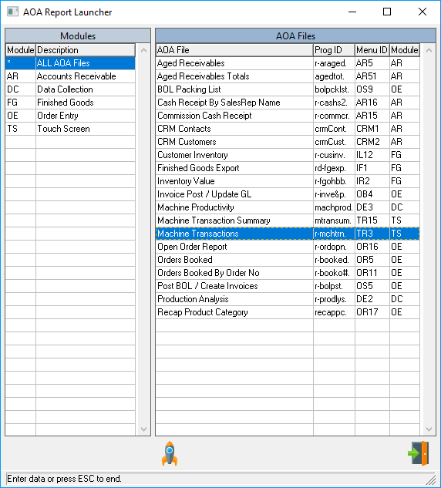

#### Launch AOA

Click the ***“Rocket”*** icon after selecting the desired *AOA Report*. Alternatively, ***“double-click”*** *the* highlighted selection to run the parameter screen.

## Report – Machine Transactions

### Report Parameters

The leftmost portion of the screen is unique *Parameters* for each *AOA Report*. When a Date Parameter exists, several predetermined values can be selected from the pull down as shown below.

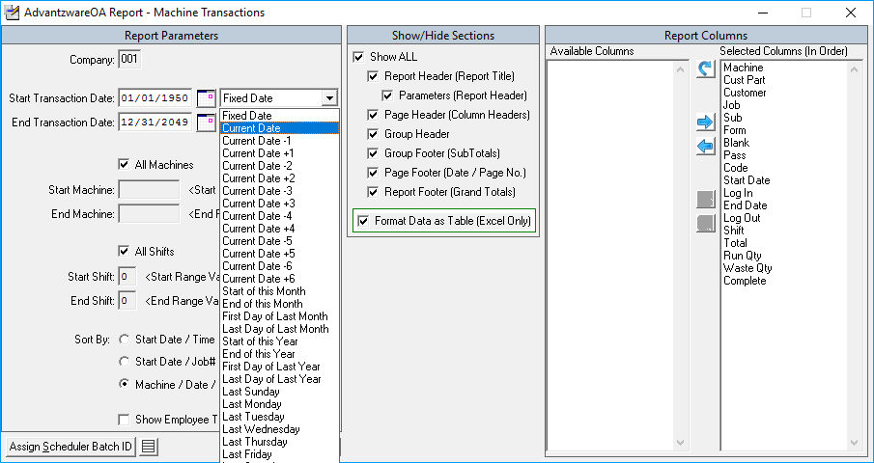

The value of these selections will be determined at run-time; this proves especially useful when an AOA Report is used in the AOA Batch Scheduler Module. Clicking the “***Calendar Icon”*** will invoke a popup Calendar to assist in specific date selections.

### Show/Hide Sections

The middle section, *Show/Hide Sections,* allows the options of showing and/or hiding various parts of an AOA Report. Clicking the *Show ALL* parameter will toggle all this section’s parameter values On/Off as applicable. The last parameter in this section *Format Data as Table (Excel Only)* determines if the data of the AOA Report is to be formatted in a Table Grid with header filters when exporting to Excel.

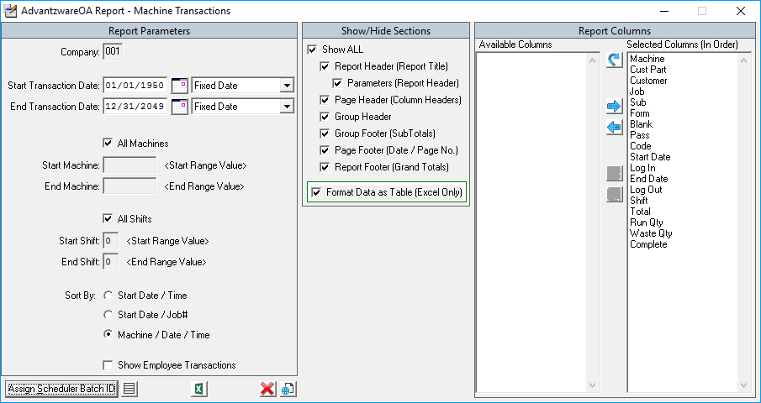

### Report Columns

The right-side columns allow for the selection and ordering of the columns which appear in the AOA Report.

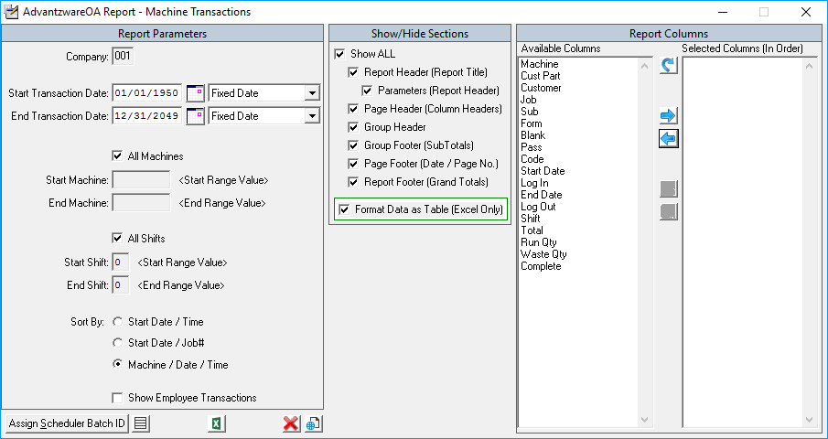

#### Report Columns Icons

|  |  |  |
| --- | --- | --- |
|  | Reset Columns to Default | This will select all Available Columns and place them in the Default order in the Selected Columns. |
|  | Add Available Column | This will add the highlighted selection(s) from *Available Columns* to the *Selected Columns.* |
|  | Remove Selected Column | This will remove the highlighted selection(s) from *Selected Columns* back to the *Available Columns.* |
|  | Move Column Up | This will move the single highlighted selection up within the list of *Selected Columns*. |
|  | Move Column Down | This will move the single highlighted selection down within the list of *Selected Columns*. |

### Render Report

Once all the parameter values are set, the Show/Hide Sections are selected and the Columns have been selected and ordered, the AOA Report is ready to be rendered to a locally installed Web Browser or exported into Excel.

## View Report

### View in Web Browser

When AOA, Application Server and IIS are installed and configured, click the “***View Icon”*** at the bottom of the screen to render the AOA Report to a Web Browser.

The below screen will appear while the AOA Report makes a connection with the Application Server.

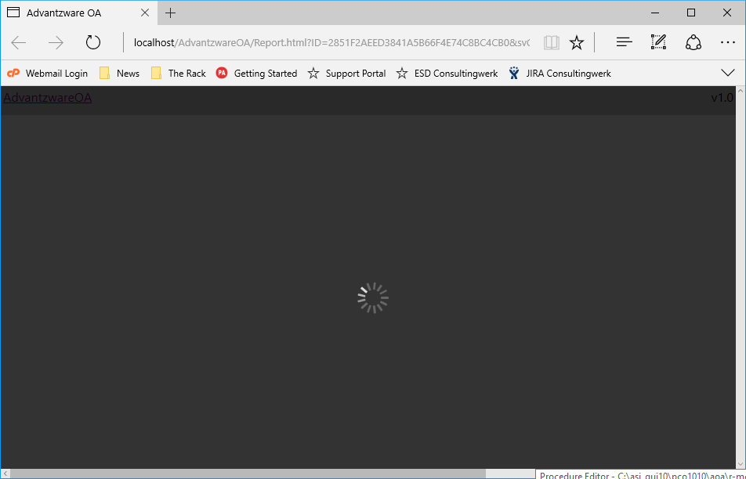

Once a connection occurs, the AOA Report executes the report query. The dialog box that appears in the upper right-hand corner allows the query to be cancelled before it completes.

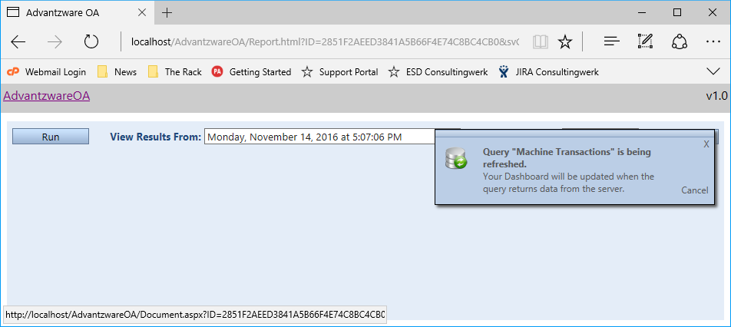

When the report query is complete, the AOA Report renders.

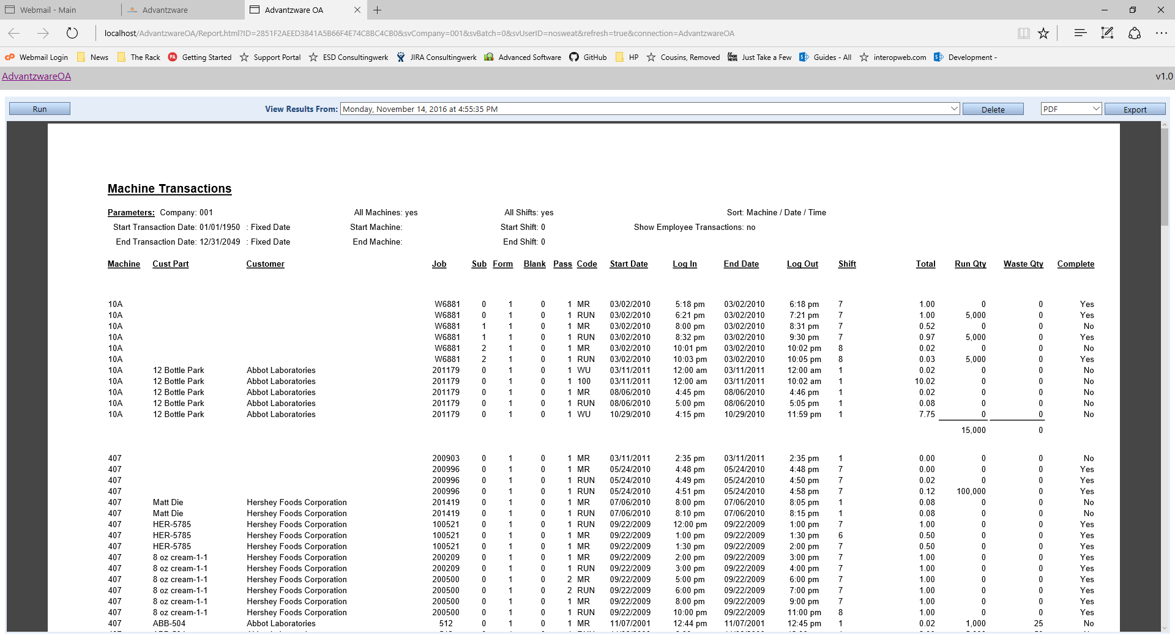

To Re-Run the AOA Report, click the “***Run***” button.

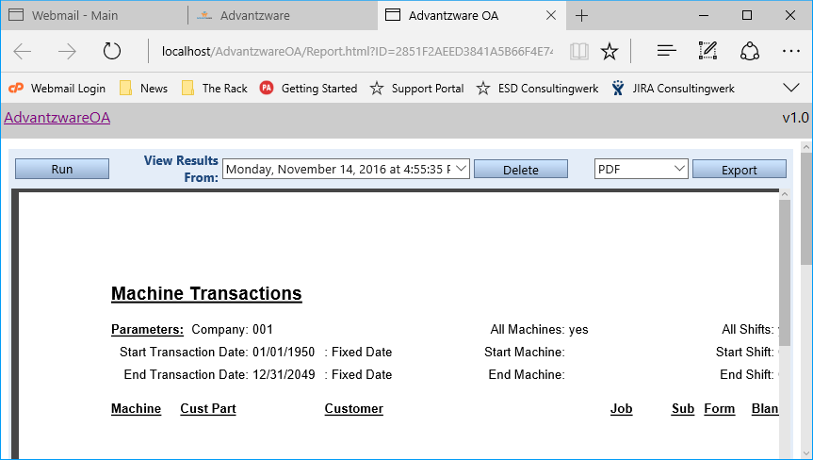

The AOA system retains the previous runs and can be viewed by selecting it from the “View Results From” drop-down menu.

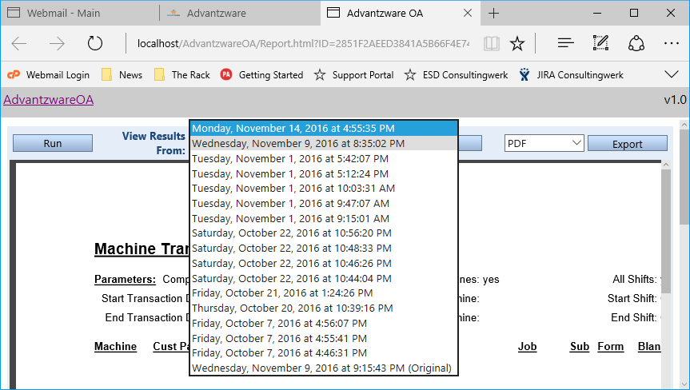

After an AOA Report is rendered, it can be Exported by selecting the type of export desired, “PDF, EXCEL or RTF” and then clicking the “***Export***” button.

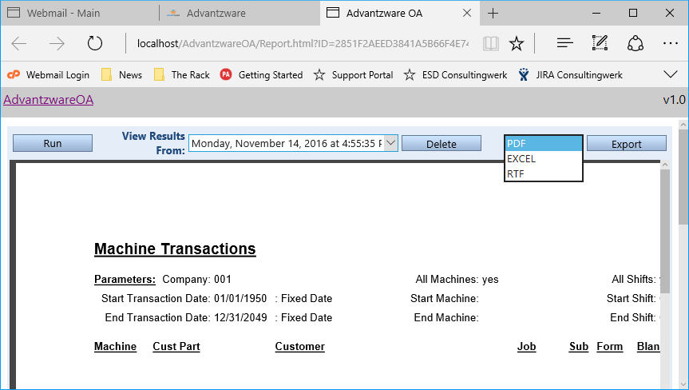

To print an AOA Report, use the Web Browser’s print functionality.

### Export to Excel

Even if none of the Applications necessary to render an AOA Report to a Web Browser are installed, an AOA Report can be exported to Excel by clicking the “***Excel Icon”***.

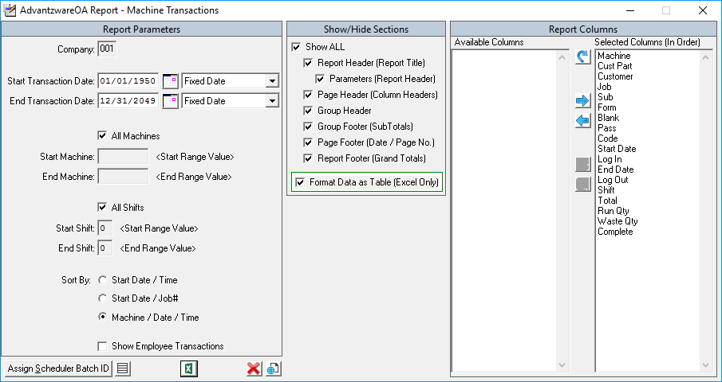

Once the report query is complete, the AOA Report renders in Excel.

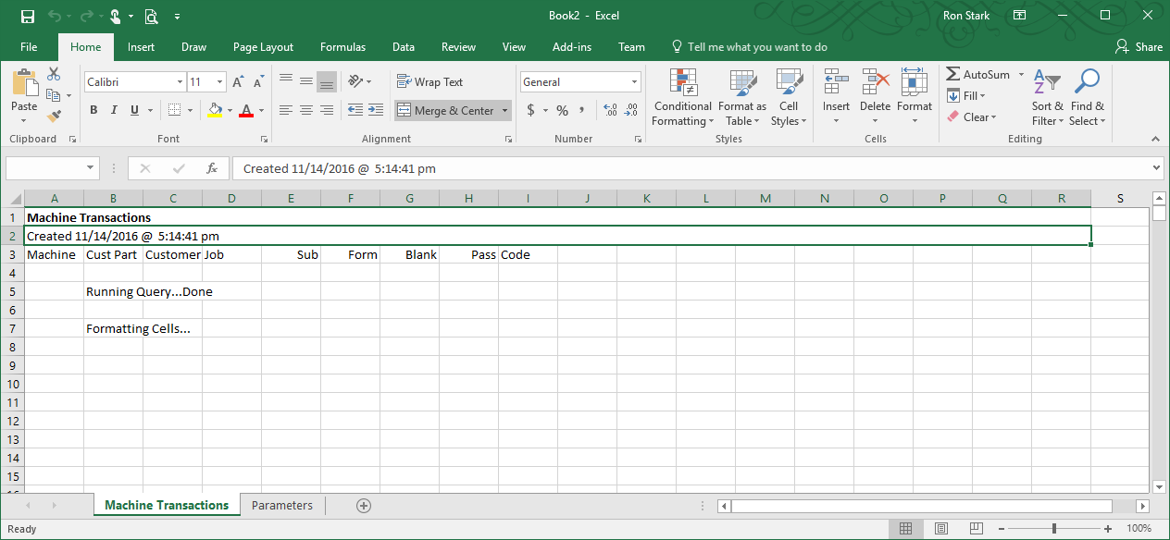

If Show Parameters is turned on, the Parameter values used by the report query can be viewed on the second sheet labeled “*Parameters*” tab.

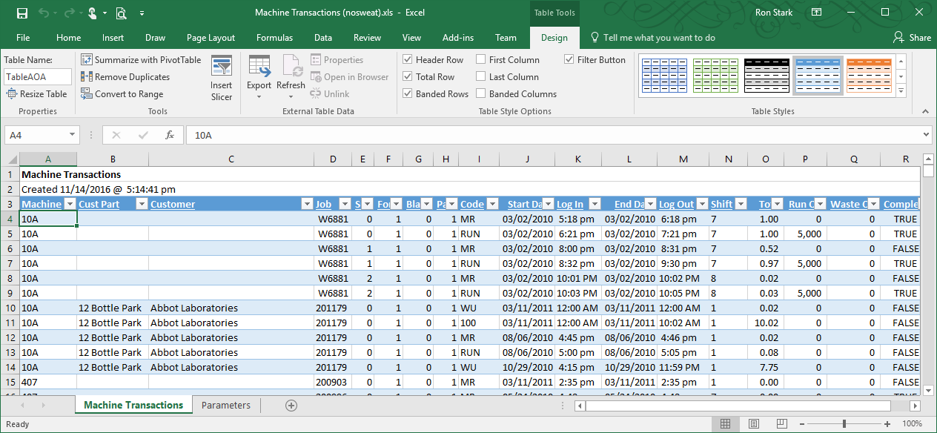

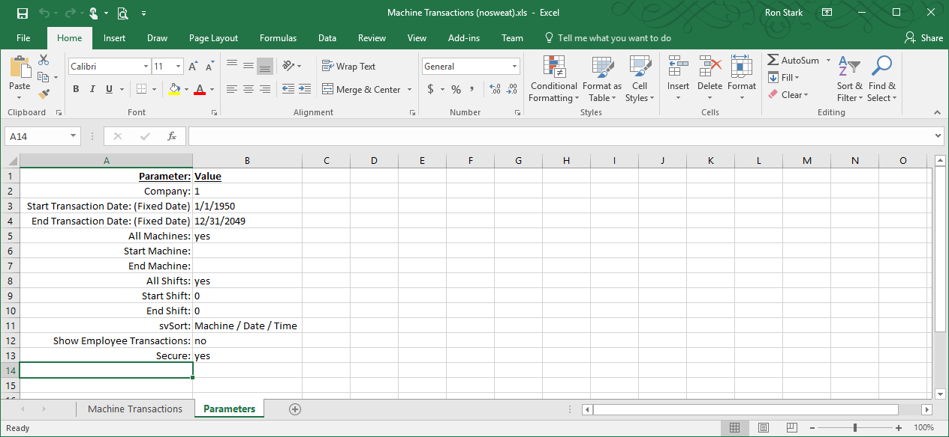

### Batch Scheduler

AOA Reports can be submitted to the *AOA Batch Scheduler,* but first a *Batch ID* must be generated to record the Parameter values for the report. Click the “***Assign Scheduler Batch ID***” button and a prompt will display showing the Batch ID value. This Batch ID value will be used in the AOA Batch Scheduler along with the Company and User ID values, to indicate what Parameter values will be used.



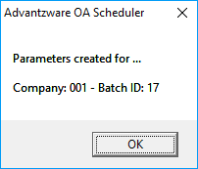

#### Batch ID Icons

|  |  |  |
| --- | --- | --- |
|  | Show Batch Parameter Values | This will access the Scheduler Batch ID’s associated with this report |
|  | Delete Batch ID | This removes the selected Batch ID. |
|  | Apply Batch Values to Parameter Values | This will populate the left side Parameters with the selected Batch ID values. |
|  | Save Parameter Value to Batch ID | This will update the selected Batch ID with the left side Parameter values. |
|  | Close | Close the AOA Parameter screen. |